**Project Report**

**Project Title:**

**Automated Car Catalog System for Enhanced Showroom Management**

**Duration: 10 Days**

**Name : Ragavi S**

**Abstract:**

The Automated Car Catalog System is designed to streamline and digitalize the management of car inventories within automobile showrooms. The system enables seamless handling of car details, including models, variants, pricing, and availability. Through automation, the platform improves operational efficiency, reduces manual workload, and enhances customer service by providing quick and accurate catalog information.

**Problem Statement:**

Car showrooms typically manage their catalog data manually, which is both time-consuming and error-prone. Handling inquiries, approvals, and assignments manually often results in delays, miscommunication, and difficulty in tracking customer preferences or service requests. This leads to inefficiencies that adversely affect customer satisfaction and showroom productivity. Hence, there is a need for an automated solution that can centralize catalog management and streamline operations.

**Introduction:**

The automobile industry relies heavily on efficient catalog and inventory management to ensure seamless customer service and operational efficiency. Traditional manual catalog systems often fail to maintain real-time updates, resulting in miscommunication and data inconsistencies. To address these challenges, an Automated Car Catalog System provides a centralized platform where various car models, their configurations, pricing, and availability can be managed digitally. This system also supports workflow automation, user role management, and a service portal that enhances transparency and reduces administrative overhead.  
The system is implemented using a structured methodology that includes requirement analysis, system design, workflow automation, and integration of service catalog features. The approach focuses on centralizing data and streamlining processes through digital forms, role-based access, and automated workflows. The platform utilizes a service portal for easy access and integrates tables and groups for organizing users and data effectively.

**Objectives**

* To automate the car catalog management process within a showroom environment.
* To centralize information regarding car models, pricing, and features.
* To reduce manual errors and improve the overall efficiency of catalog handling.
* To enable quick retrieval of data for customer queries and internal operations.
* To support better workflow and approval processes through automation.

**Methodology**

The development of the Automated Car Catalog System follows a structured process beginning from requirement gathering to design and implementation. The methodology ensures that the car catalog data is efficiently stored, retrieved, and managed through automated workflows and a service portal.

**Step-by-Step Workflow**

1. **Requirement Analysis** – Identification of showroom needs and user roles.
2. **System Design** – Creation of service catalog structure, user groups, and access roles.
3. **Table Creation** – Designing structured storage for catalog and service request data.
4. **Workflow Configuration** – Automation of approvals and task assignments.
5. **Portal Integration** – Allowing users to request and view catalog information.
6. **Testing and Validation** – Ensuring smooth operation and error-free data handling.
7. **Deployment** – Making the system available for showroom users.

**Modules Involved**

1. **Service Catalog** - Manages all available services related to the car catalog and customer queries.
2. **User Creation** - Allows creation of different user accounts based on roles and responsibilities.
3. **Role Creation** - Defines various roles such as admin, manager, and sales representative.
4. **Group Creation** - Organizes users into groups for simplified data and workflow management.
5. **Table Creation** - Stores structured catalog and transactional data.
6. **Workflow** - Ensures smooth approval and request-handling processes through automation.
7. **Service Portal** - Provides a user-friendly interface for customers and staff to interact with the system.
8. **Result** - Displays outcomes of requests, catalog updates, and system interactions.

**Result**

The implemented system successfully automates car catalog management and improves the workflow within the showroom. The automation reduces manual errors, simplifies user tracking, and enhances the speed with which data is retrieved and presented. This leads to improved efficiency and better customer service.

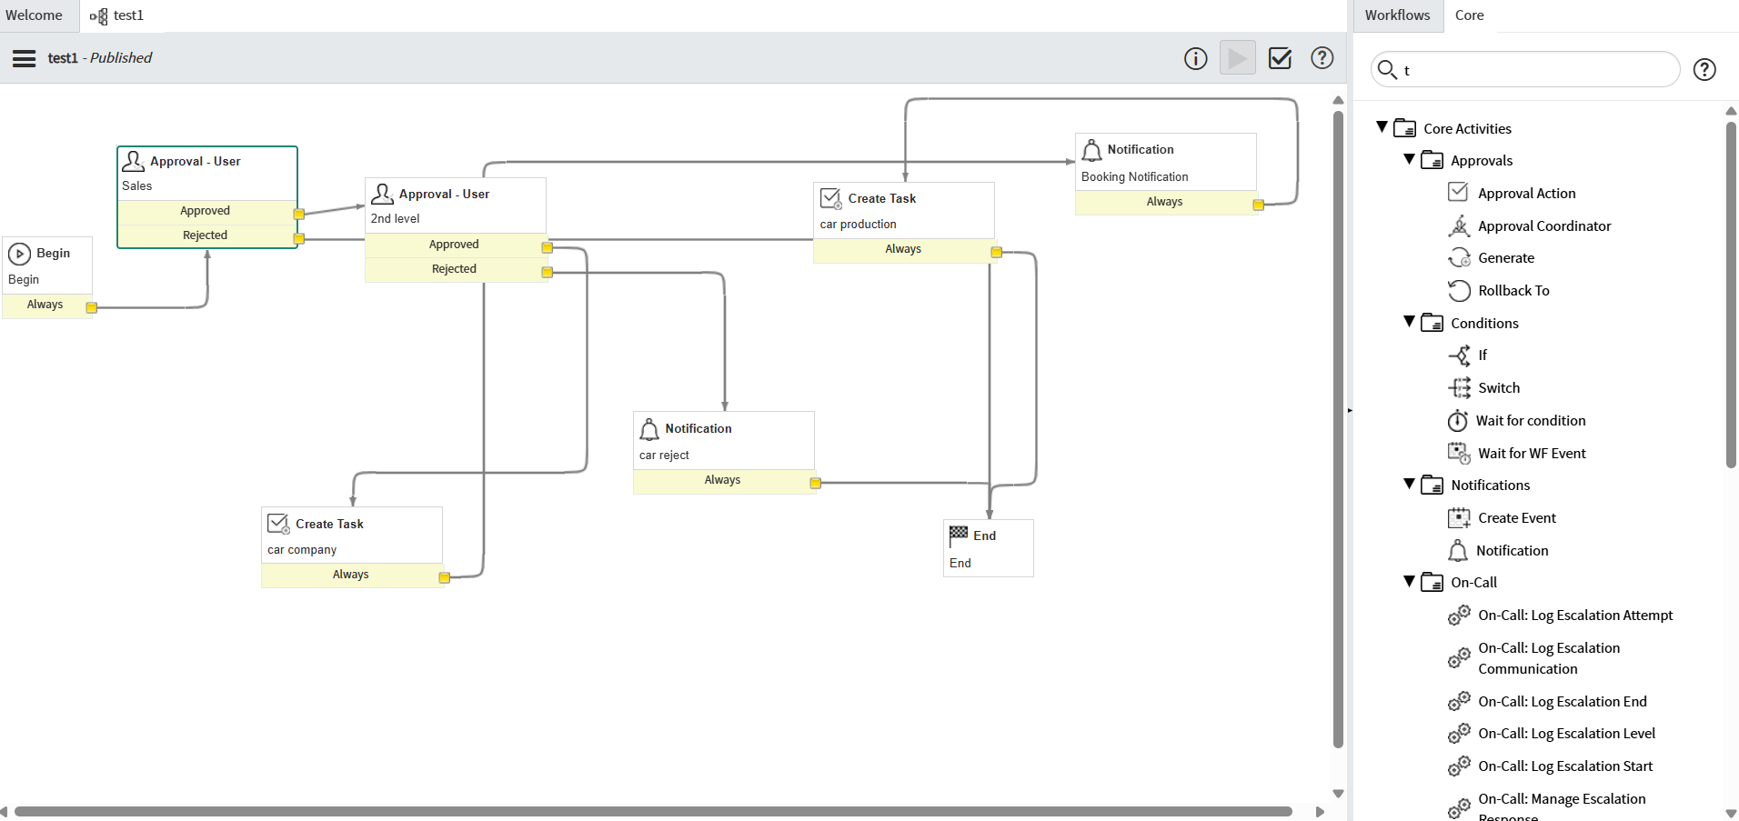

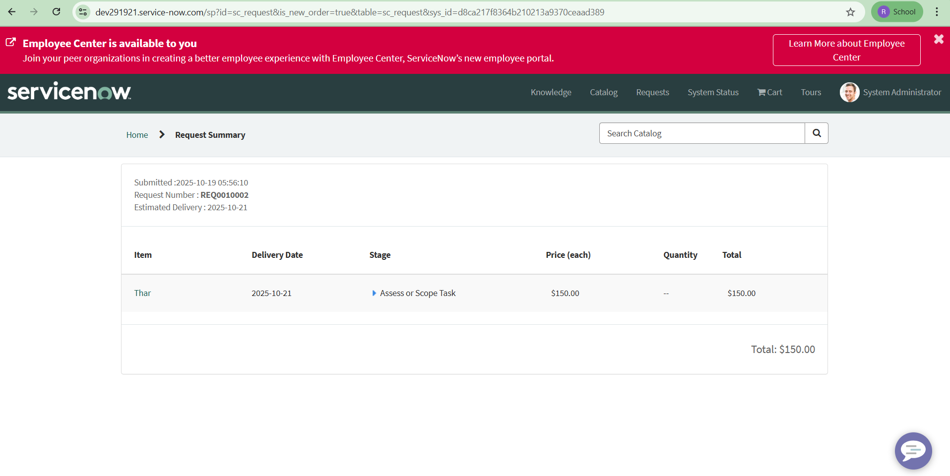

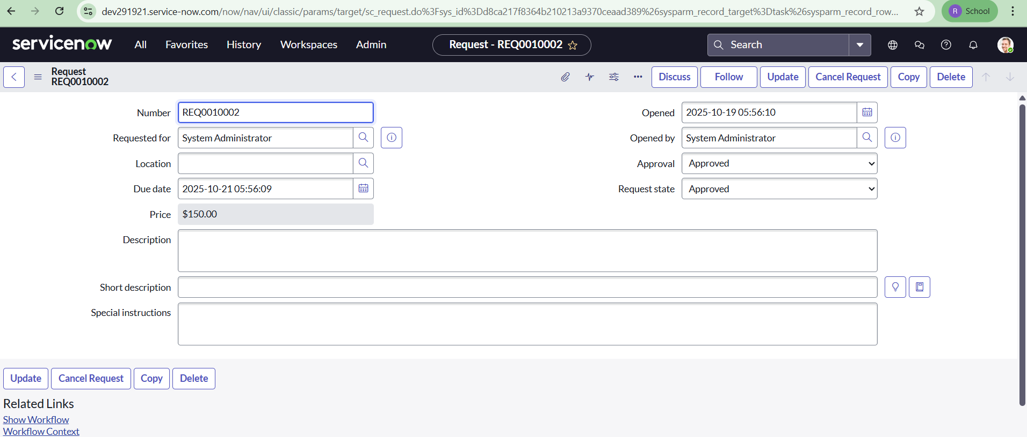



**Conclusion**

The Automated Car Catalog System has proven to be an effective solution for simplifying and optimizing showroom catalog operations. By centralizing data and streamlining workflows, the system reduces manual dependencies and enhances productivity. It provides a more transparent and responsive environment for both staff and customers.

**Future Enhancement**

* Integration with live inventory tracking and supplier updates.
* Addition of analytics and reporting dashboards for better decision-making.
* Implementation of AI-based recommendations for customers.
* Mobile app support for remote catalog access.
* Chatbot integration for faster customer interaction.

**Reference**

1. • ServiceNow Product Documentation — https://docs.servicenow.com
2. • ServiceNow Developer Portal — https://developer.servicenow.com
3. • IT Service Management Fundamentals — https://www.servicenow.com/itsm.html
4. • Workflow Automation Concepts — https://www.servicenow.com/platform/workflow.html